|  |  |
| --- | --- |
| The Logo of Land Registry | **THE LAND REGISTRY** |

**MEMORIAL DAY BOOK (MDB) ON CD-ROM**

**Order Form**

# Part I. Particulars

|  |  |  |  |  |  |  |  |  |  |  |  |  |  |  |  |
| --- | --- | --- | --- | --- | --- | --- | --- | --- | --- | --- | --- | --- | --- | --- | --- |
| Name | | | | | : |  | | | | | | | | | |
| E-mail Address for Correspondence | | | | | : |  | | | | | | | | | |
| Address | | | | | : |  | | | | | | | | | |
| Delivery Address | | | | | : |  | | | | | | | | | |
| (if different from the above address) | | | | | | | | | | | | | | | |
| Telephone No. | | | : |  | | | | | | | Fax No. (Optional) | | : | |  | |
|  | | | | | | |  |  | | | | | | | | |
| Business Type | : | 1. | | Accountants Firm | | | | | 2. | Bank | | 3. | | Finance / Investment Co. | |
|  |  | 4. | | Newspaper & Publisher | | | | | 5. | Real Estate Developer | | 6. | | Real Estate Broker & Agent | |
|  |  | 7. | | Search Co | | | | | 8. | Solicitors Firm | | 9. | | Surveyors Firm / Valuation Consultant | |
|  |  | 10. | | Public Utility | | | | | 11. | Government Department | | 12. | | Quasi Government Organization | |
|  |  | 13. | | Others | | | | |  | | | | | | |

🞏 Please put a tick “🗸” where appropriate

# Part II. Details of Order

1. I wish to order    set(s) of the CD-ROM which contains the MDB for the calendar year       @HK$2,620 per set (see Note (i) & (ii)).
2. I enclose herewith a * cheque / demand draft / cashier’s order no.       payable to “The Government of the Hong Kong Special Administrative Region” or “The Land Registry” in the amount of HK$      for the order.

I pay HK$      by *PPS/ Credit Card/ Mobile Payment/ e-Cheque (*for online submission only*) for the order.

Note: (i) The price shall be subject to change as may from time to time be determined by the Land Registry.

(ii) Postage will be charged where delivery outside Hong Kong is required.

* Delete whichever is inappropriate 🞏 Please put a tick “🗸” where appropriate

# Part III. Declaration

1. I have read and understand the “Personal Information Collection Statement” printed overleaf/attached and confirm that the information given above is correct and complete.
2. I have read and understand the Terms and Conditions printed overleaf/attached for the purchase of MDB on CD-ROM and agree to be bound by such Terms and Conditions.
3. I understand that if my order for the purchase of MDB on CD-ROM is not accepted, the payment mentioned in para.2 of Part II above will be refunded to me.

|  |  |  |  |
| --- | --- | --- | --- |
| Authorised signature [with chop] : |  | Title of signatory :  (e.g. Partner, Director) |  |
| Full name of signatory: |  | Date of Application : |  |

Please return the completed form to the Subscribers’ Accounts Section, Financial Services Division, Land Registry, 28/F, Queensway Government Offices, 66 Queensway, Hong Kong. If you submit the application form via electronic mail, please refer to the Land Registry's website (<http://www.landreg.gov.hk/en/services/services_b_7.htm>) for details. For enquiry, please call 2867 8069.

**“PLEASE SEE IMPORTANT CONDITIONS OVERLEAF/ATTACHED”**

**FOR OFFICE USE ONLY**

|  |  |  |  |  |  |
| --- | --- | --- | --- | --- | --- |
| Approved by | : |  | Approval Date | : |  |
| Order Number | : |  | Delivery Date | : |  |

Terms and Conditions

1. The Purchaser agrees to purchase, and the Land Registry agrees to sell, the CD-ROM which contains data as defined in Clause 2 (which data are hereinafter called "**MDB**") for such calendar year at such price as specified in the Order Form (attached or printed overleaf) and subject to this terms and conditions set out in this agreement (including the terms and conditions set out in the Order Form and the Personal Information Collection Statement attached or printed overleaf).

1A. On acceptance of the Purchaser’s order, in addition to delivering the CD-ROM to the Purchaser, the Land Registry will also send the Purchaser an email to the Purchaser’s email address (as provided by the Purchaser in the Order Form) with hyperlink(s) for the Purchaser to download the relevant MDB from the Land Registry’s website (“Online data”). The relevant hyperlink(s) will be valid for 30 days after the date of issuance of the email.

2. In this agreement, "**MDB**" means such data as contained in the Memorial Day Book(s) kept or available in the Land Registry which comprises of the memorial particulars of documents delivered or lodged with the Land Registry for registration everyday pursuant to the Land Registration Ordinance (Cap.128) and its regulations.

3. The CD-ROM ordered under this agreement and Online data available for downloading on the Land Registry’s website (collectively referred to as “Product”) contain MDB in files prepared by the Land Registry in a form known as **MDB data files**.

4. The Purchaser shall be solely responsible for the acquisition of his own computer equipment, software, skills, internet access and/or other technical support in order to have access to the contents of the MDB data files contained in the Product. Guidelines may be given from time to time by the Land Registry to the Purchaser as to access to the content of the MDB data files, but the Land Registry shall not be responsible in whatever respect in connection therewith.

5. Full payment of the purchase money shall be made by the Purchaser to the Land Registry upon submission of the Order Form. All orders are subject to acceptance by the Land Registry. The Land Registry may reject any order in total or in part without assigning any reason.

6. The MDB shall not be used by any person other than the Purchaser, nor shall the MDB be used for any purpose other than the Purchaser's own use. The Purchaser shall not lend, lease, license or resell the MDB in its original Product form or in any other form. The Purchaser shall not copy or reproduce or transmit the MDB or any part thereof in any form by any means for use by any person other than the Purchaser.

6A. The hyperlink(s) provided by the Land Registry under Clause 1A shall not be used by any person other than the Purchaser. The Purchaser shall not share, transmit or in any other way disclose the said hyperlink(s) to any other person. If the Land Registry suspects that the hyperlink(s) has/have been disclosed to any third party, it may invalidate the hyperlink(s) at any time without prior notice.

7. The Purchaser shall not use the MDB for activities which are unlawful or which are objectionable as determined by the Land Registry absolutely. In particular, the MDB shall not be used for activities in violation of any provisions of the Personal Data (Privacy) Ordinance (Cap.486) ("**PDPO**") or the Copyright Ordinance (Cap.528).

8. The Land Registry shall not be responsible for the accuracy, completeness and/or consistency of the MDB nor shall the Land Registry be required to make any subsequent amendments to the MDB data file or files after they have been delivered to the Purchaser. Upon production of the delivery note and the defective CD-ROM with its original package, a defective CD-ROM may be returned for replacement within 7 days of delivery. Replacement is subject to the Land Registry’s testing and satisfaction that the defect(s) existed as alleged at the time of delivery. No refund of purchase money is available in such event, nor a replacement shall be construed as a breach or late delivery on the part of the Land Registry.

9. The Land Registry reserves the right to amend any particular format, layout and/or transmission media of the MDB and also to add to, delete and/or to vary the types of information as contained in the MDB or the MDB data files. No previous dealings between the Land Registry and the Purchaser or previous practice of the Land Registry in this regard shall be relied on by the Purchaser.

10. The Purchaser's rights under the terms and conditions herein shall be personal and cannot be assigned or transferred to any third party.

11. The Purchaser hereby authorizes the Land Registry to provide third party with such information relating to the Purchaser in order to comply with any order of any court or tribunal or a request from a government agency or authority of local or foreign jurisdiction.

12. The Purchaser shall notify the Land Registry immediately upon any change of the particulars given in the Part I “Particulars” of the Order Form.

13. Notices to be given to the Purchaser shall be sufficient and deemed to be given to the Purchaser if given in writing and served by hand delivery, by post or by fax to the address or fax number provided by the Purchaser to the Land Registry in the Order Form.

14. The terms and conditions herein shall be governed by and construed according to the laws of Hong Kong. Any disputes between the parties arising out of this agreement shall be submitted to the adjudication by the courts of Hong Kong.

**PERSONAL INFORMATION COLLECTION STATEMENT**

Purpose of Collection

1. The personal data collected will be used by the Land Registry for the following purposes:-

1.1 to carry out activities and the Land Registry’s functions relating to the provision of services by the Land Registry;

1.2 to facilitate communications; and

1.3 to produce statistics relating to the Land Registry’s services.

You understand that the provision of personal data is obligatory. If you fail to provide information as required, the Land Registry may not be able to provide the requested service.

Please do NOT provide any personal data (including personal data relating to third parties) which are not specifically required to be submitted. Where information of any third party is included in this form or any document(s) filed in relation to it, the Land Registry will treat that you have obtained consent from such third party to disclose such information for the purposes above.

Disclosure of Personal Data

2. You understand that the personal data provided may be disclosed or transferred to relevant parties where such disclosure or transfer is necessary for the purposes as stated in paragraph 1 above. Such personal data may also be disclosed or transferred to law enforcement agencies as permitted under the Personal Data (Privacy) Ordinance (Cap.486) (“PDPO”).

Access to Personal Data

3. You understand that pursuant to Sections 18 and 22 and Principle 6 of Schedule 1 to the PDPO, you have the right to request access to and correction of your personal data held by the Land Registry. The Land Registry may charge a fee to process the said request in accordance with the PDPO. Any such request shall be made to the Personal Data (Privacy) Officer of the Land Registry at 28th Floor, Queensway Government Offices, 66 Queensway, Hong Kong.

|  |  |
| --- | --- |
| The Logo of Land Registry | **THE LAND REGISTRY** |

# MEMORIAL DAY BOOK (MDB) ON CD-ROM

## Product

* 1. MDB data files of the whole calendar year.

## Product Description

* 1. MDB data files which contain MDB particulars of each calendar day for the year are supplied on a single CD-ROM. Before IRIS implementation on 12 February 2005, there are two sub-directories: one for Urban MDB and the other for NT MDB. Each sub-directory contains 5 MDB files. Subsequently, after IRIS implementation, the Urban and NT registers are merged into an integrated systems and thus, the 5 MDB files under each day directory represent all MDB data of that particular date. Please note that there are also some minor changes in the file format of the 5 MDB files after IRIS implementation.
  2. Total size of the 5 data files within each day directory is up to 3 MB, depending on the number of memorials involved. Total size of all data files on the CD-ROM is about 620 MB.
  3. The Land Registry will also send an email to the Purchaser’s email address with hyperlink(s) for the Purchaser to download the relevant MDB from the Land Registry’s website (“Online data”). The relevant hyperlink(s) will be valid for 30 days after the date of issuance of the email.
  4. Record layouts of MDB data files and sample data contents are illustrated at Annex 1 (Urban MDB), Annex 2 (NT MDB) and Annex 3 (Post-IRIS MDB) respectively.

## Hardware and Software Configuration

* 1. Purchasers are required to acquire their own computer equipment, software, internet access and skills for accessing the contents of the MDB data files contained in CD-ROM and Online data downloaded from the Land Registry’s website.

## Charges

* 1. HK$2,620 per set of CD-ROM.

## Terms and Conditions of Use

* 1. The Terms and Conditions are attached to the Order Form.

## Delivery of CD-ROM

* 1. Free courier delivery for local purchases within 14 working days after receipt of the completed Order Form and the related payment. Postage will be charged where delivery outside Hong Kong is required.

## Application

* 1. Apply to the Land Registry on Order Form [LR/MDB/2 (Rev.6/2023)].

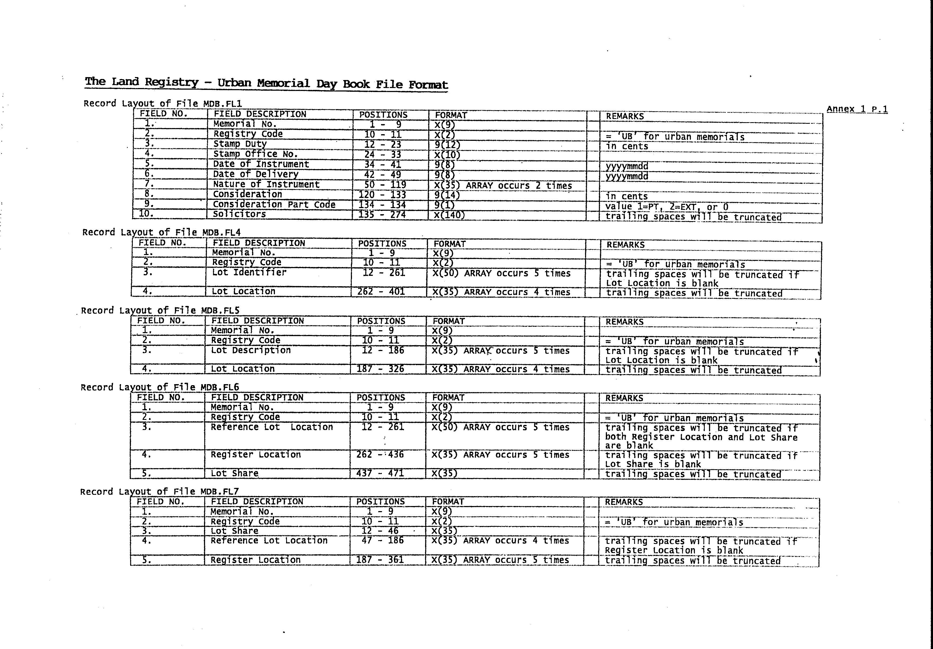

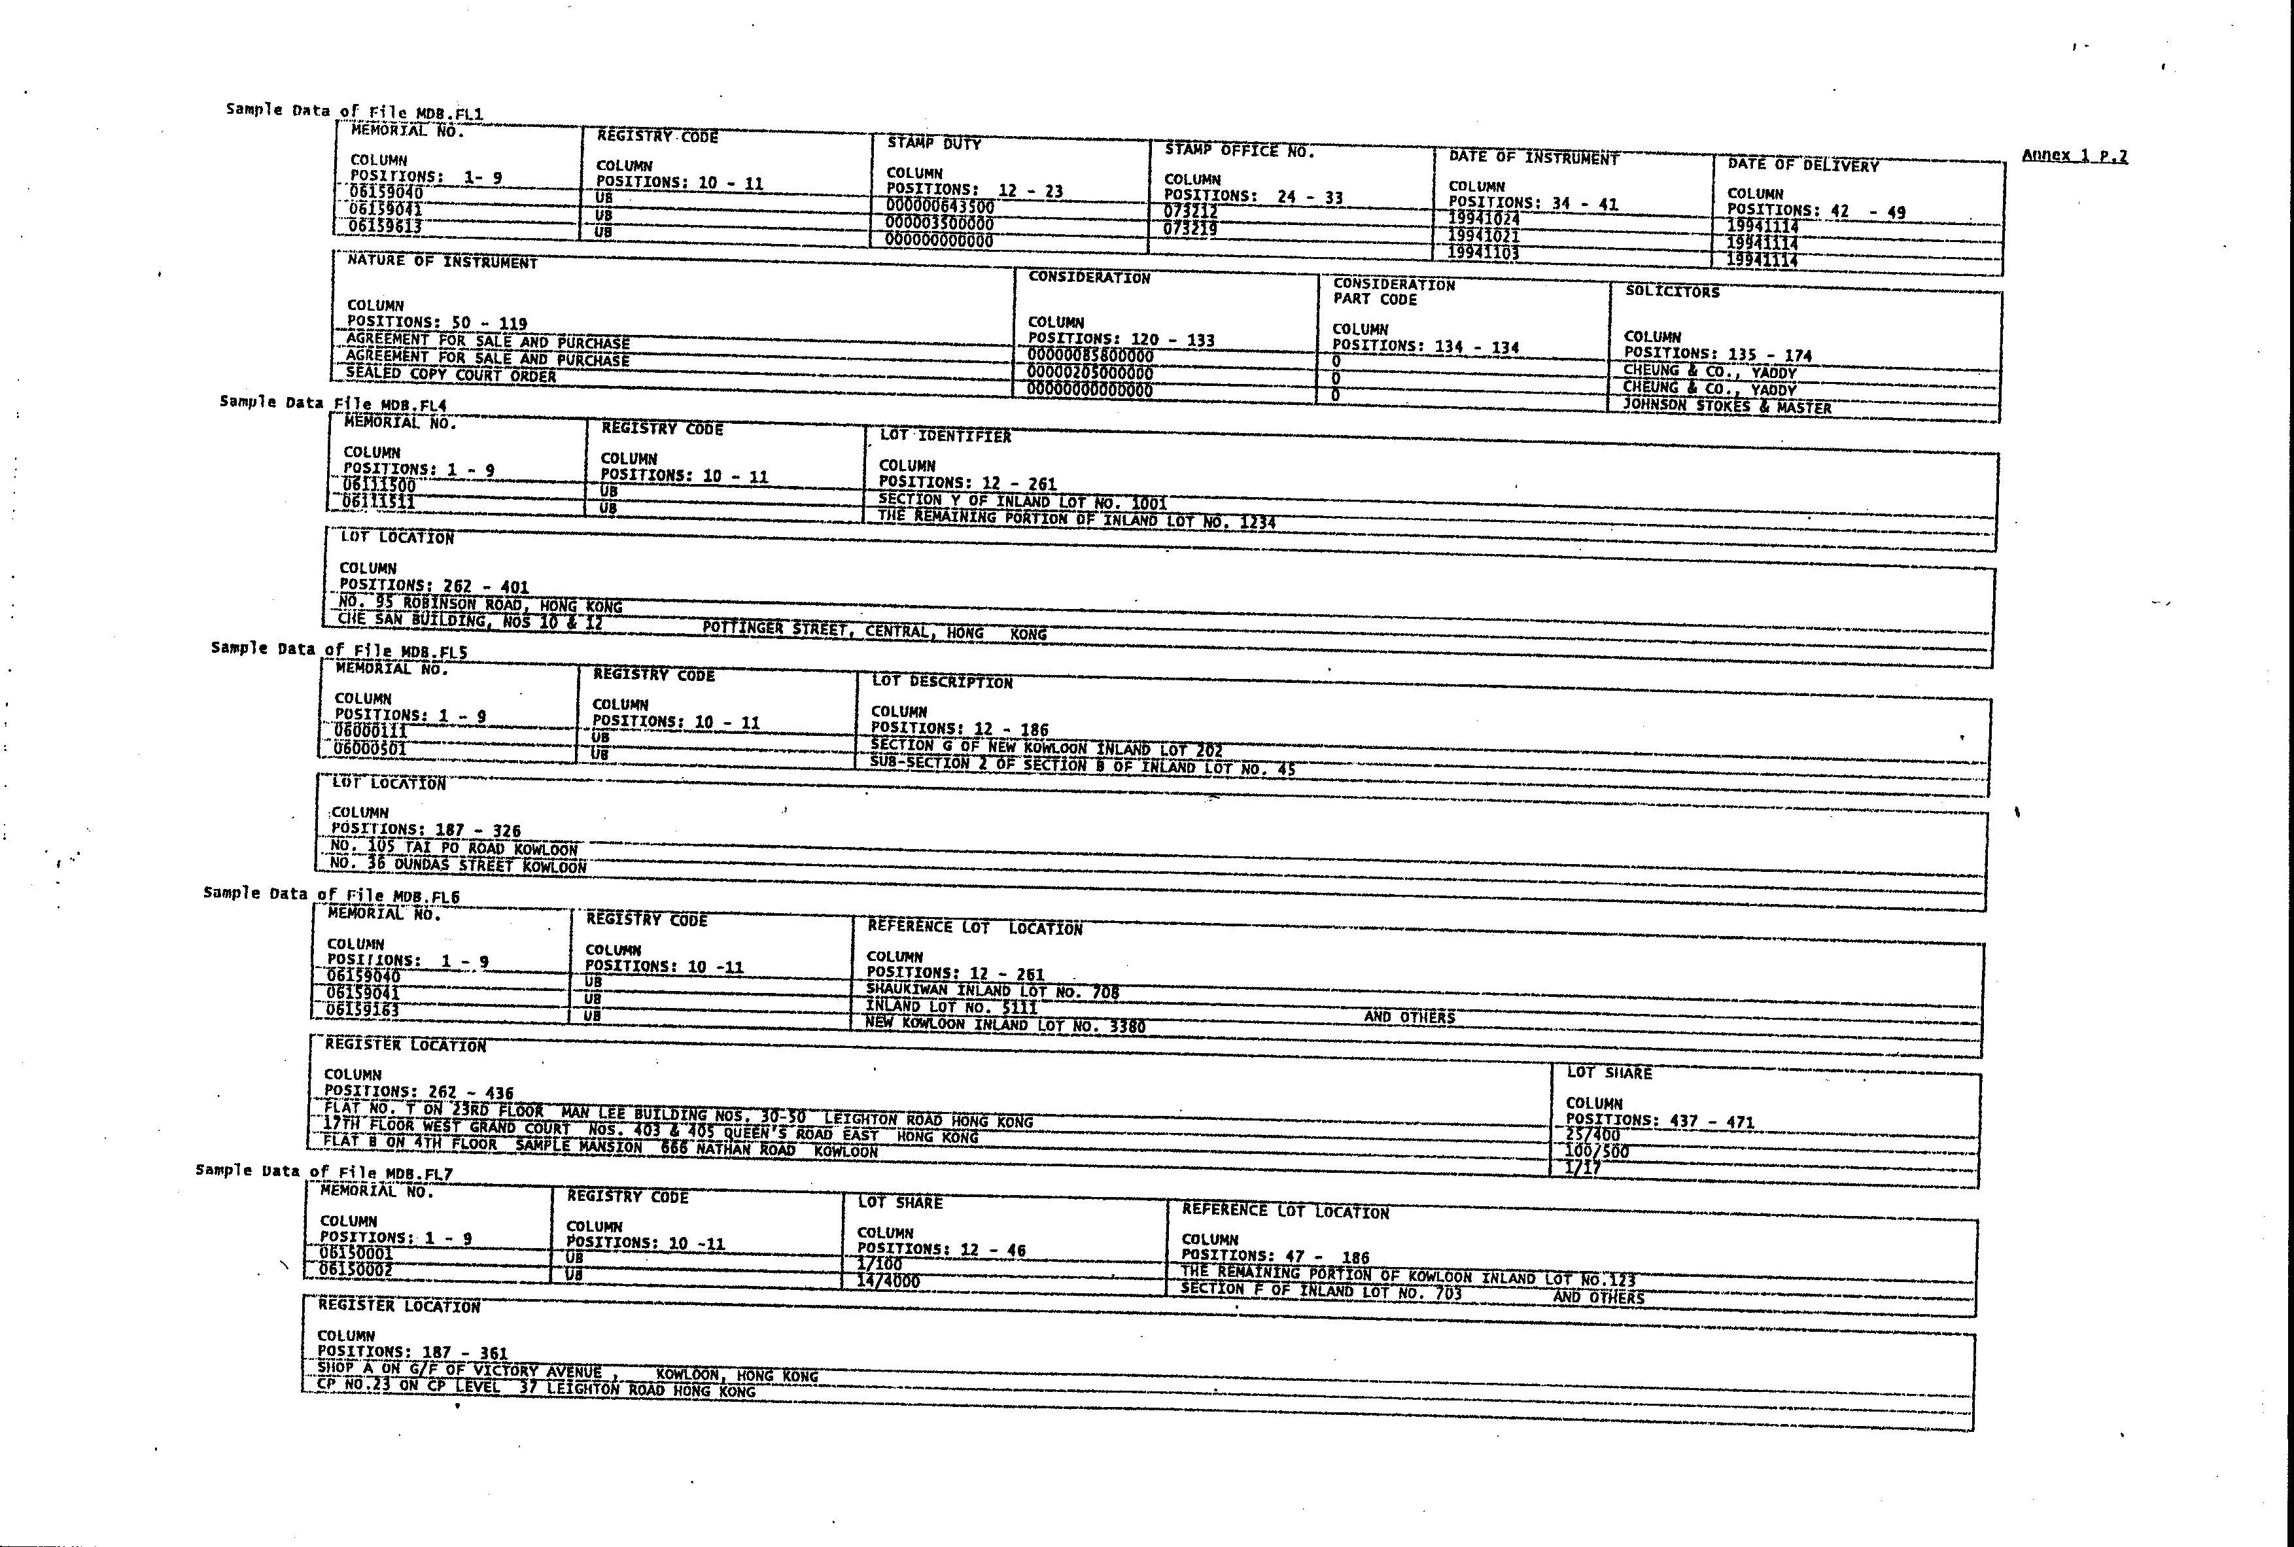

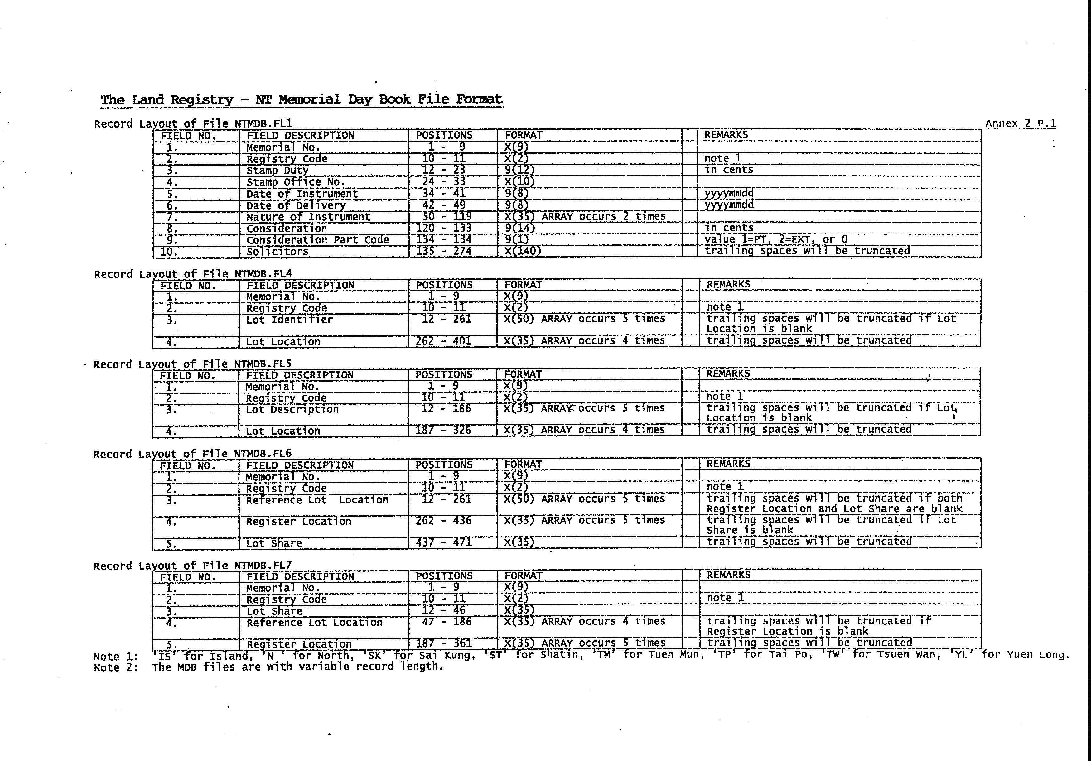

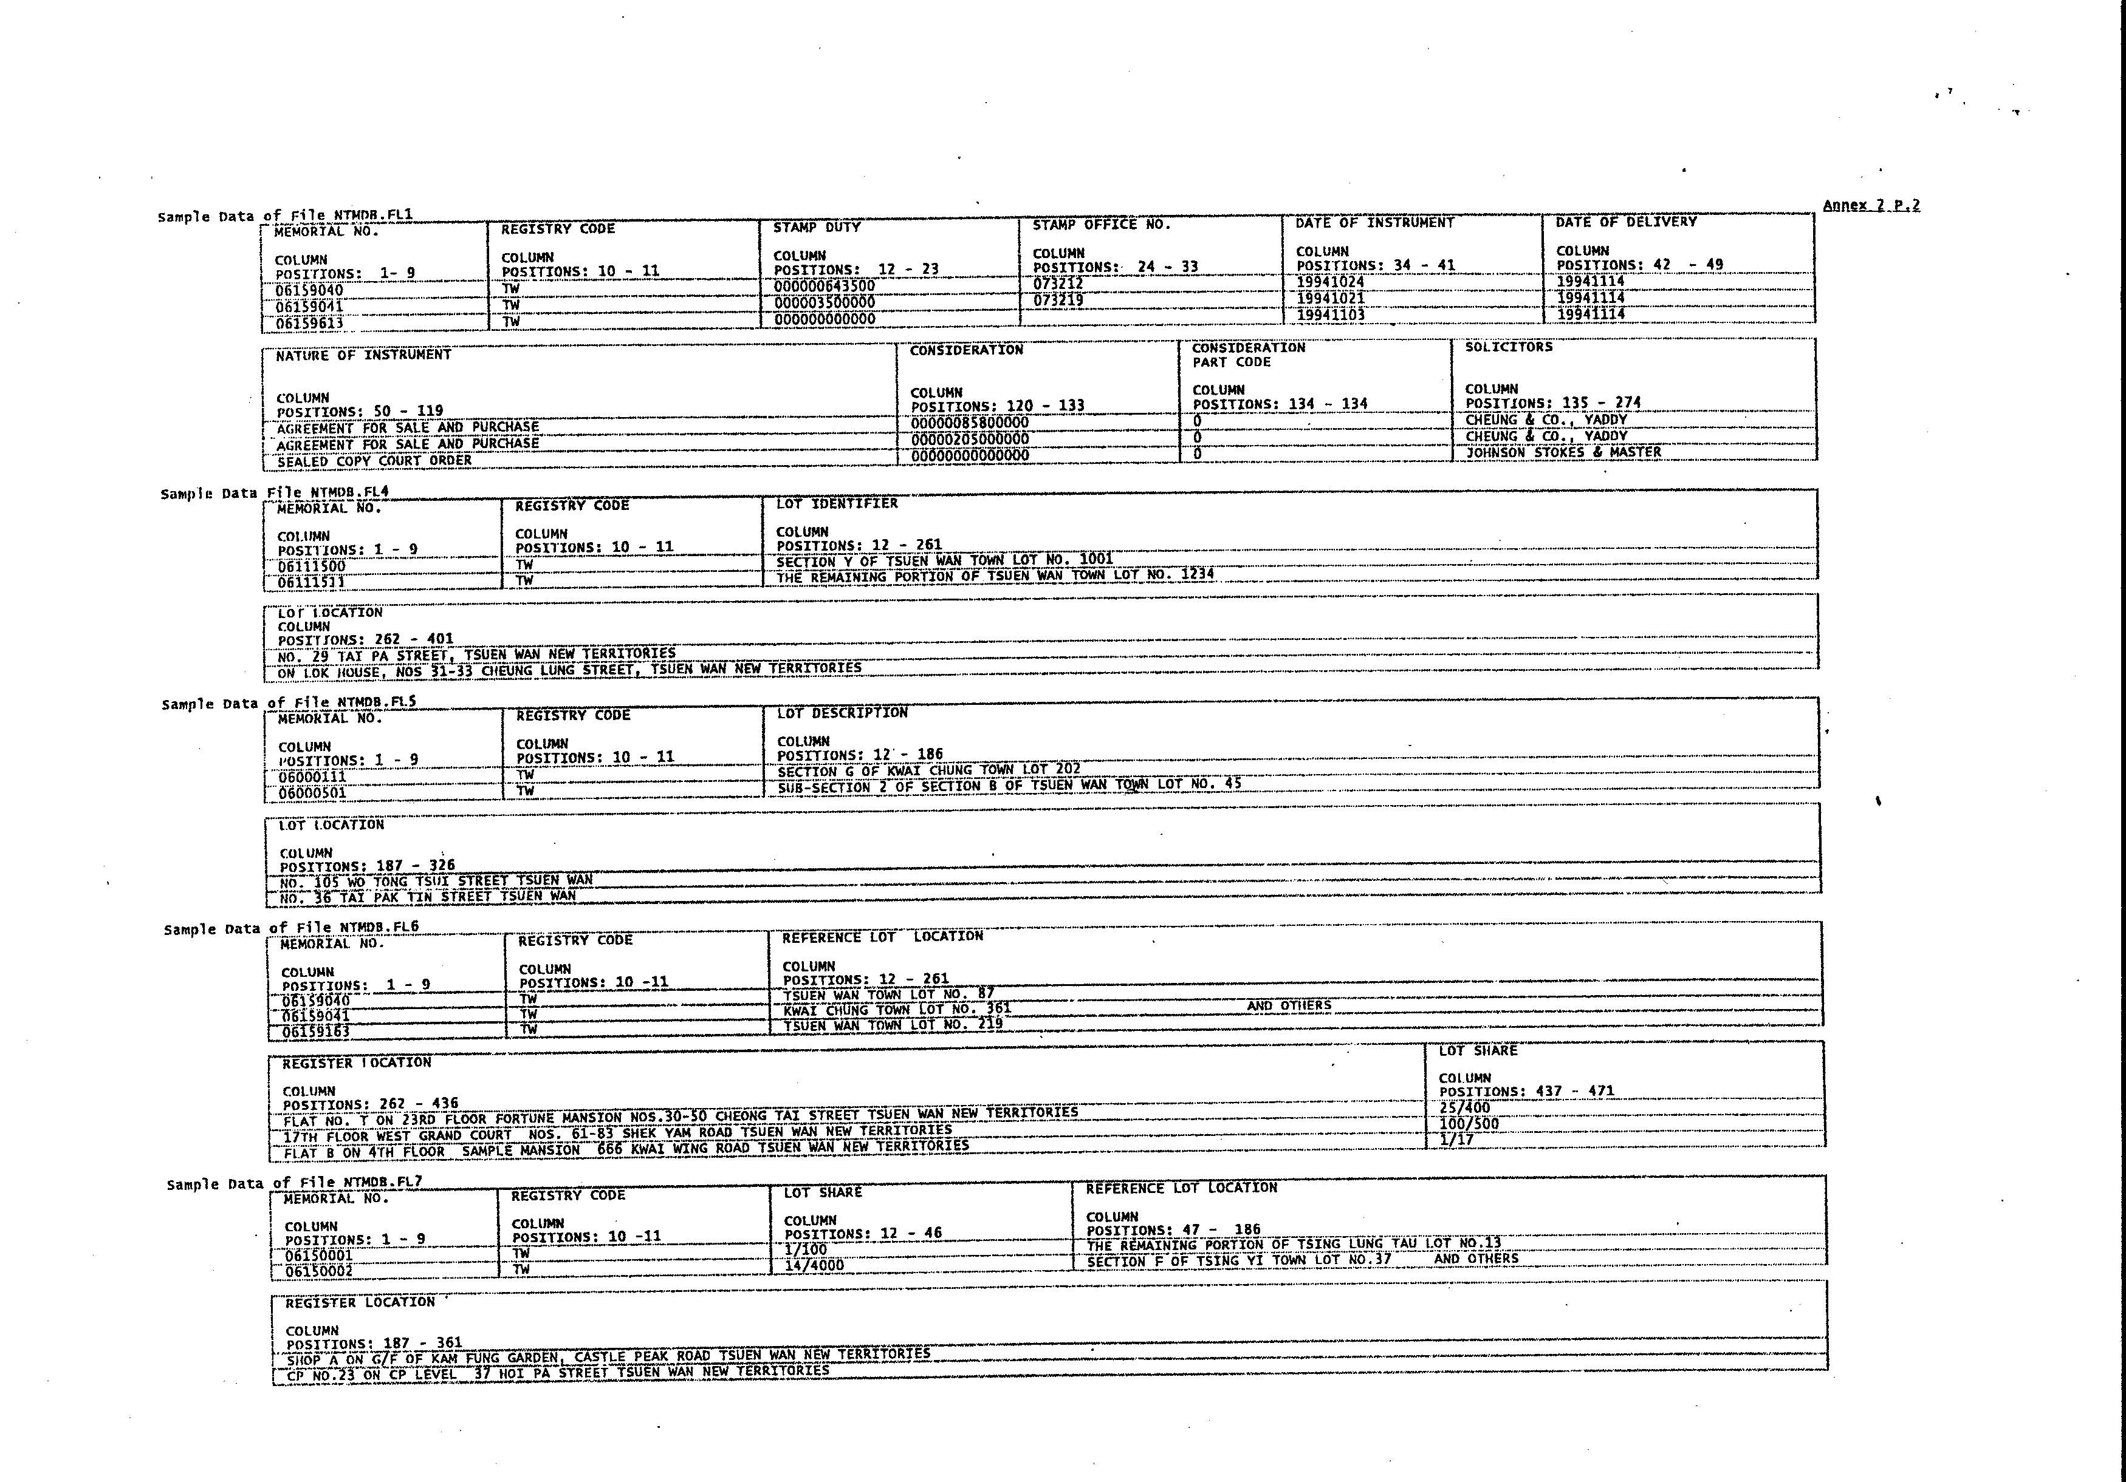

###### **The Land Registry – Integrated Registration Information System Memorial Day Book File Format**

Annex 3 P. 1

Record Layout of File MDB.FL1

|  |  |  |  |  |  |
| --- | --- | --- | --- | --- | --- |
| **Field No** | **Field Description** | **Position** | **Format** |  | **Remarks** |
|  | Memorial Number | 1 - 14 | X(14) |  |  |
|  | Stamp Duty | 15 - 28 | 9(14) |  | In cents. Right-justified with no leading zero. |
|  | Stamp Office Instrument Reference Number | 29 - 44 | X(16) |  |  |
|  | Date of Instrument | 45 - 52 | 9(8) |  | In yyyymmdd date format. |
|  | Date of Delivery | 53 - 60 | 9(8) |  | In yyyymmdd date format. |
|  | Nature of Instrument | 61 - 165 | X(105) |  |  |
|  | Consideration (HK$) | 166 - 181 | 9(16) |  | In cents. Right-justified with no leading zero. |
|  | Consideration (Text) | 182 - 281 | X(100) |  |  |
|  | Consideration Part Code | 282 - 285 | X(4) |  |  |
|  | Solicitors | 286 - 425 | X(140) |  | Trailing spaces will be truncated. |

Record Layout of File MDB.FL4

|  |  |  |  |  |  |
| --- | --- | --- | --- | --- | --- |
| **Field No** | **Field Description** | **Position** | **Format** |  | **Remarks** |
|  | Memorial Number | 1 - 14 | X(14) |  |  |
|  | Property Reference Number | 15 - 22 | X(8) |  |  |
|  | Lot Identifier | 23 - 342 | X(320) |  | Trailing spaces will be truncated if Lot Locations (both Chinese and English) are blank. |
|  | Lot Location (English) | 343 - 683 | X(341) |  | Trailing spaces will be truncated if Lot Location (Chinese) is blank.  If the current entry has reached the pre-defined number of registers that can be displayed for a memorial, “ AND OTHER PROPERTIES” will be appended. |
|  | Lot Location (Chinese) | 684 -1333 | X(650) |  | Trailing spaces will be truncated. The Chinese character is encoded in Unicode (UTF-8).  If the current entry has reached the pre-defined number of registers that can be displayed for a memorial, “及其他物業” will be appended. |

Record Layout of File MDB.FL5

|  |  |  |  |  |  |
| --- | --- | --- | --- | --- | --- |
| **Field No** | **Field Description** | **Position** | **Format** |  | **Remarks** |
|  | Memorial Number | 1 - 14 | X(14) |  |  |
|  | Property Reference Number | 15 - 22 | X(8) |  |  |
|  | Lot Description | 23 - 342 | X(320) |  | Trailing spaces will be truncated if Lot Locations (both Chinese and English) are blank. |
|  | Lot Location (English) | 343 - 683 | X(341) |  | Trailing spaces will be truncated if Lot Location (Chinese) is blank.  If the current entry has reached the pre-defined number of registers that can be displayed for a memorial, “ AND OTHER PROPERTIES” will be appended. |
|  | Lot Location (Chinese) | 684 - 1333 | X(650) |  | Trailing spaces will be truncated. The Chinese character is encoded in Unicode (UTF-8).  If the current entry has reached the pre-defined number of registers that can be displayed for a memorial, “及其他物業” will be appended. |

Record Layout of File MDB.FL6

|  |  |  |  |  |  |
| --- | --- | --- | --- | --- | --- |
| **Field No** | **Field Description** | **Position** | **Format** |  | Remarks |
|  | Memorial Number | 1 - 14 | X(14) |  |  |
|  | Property Reference Number | 15 - 22 | X(8) |  |  |
|  | Lot Share | 23 - 78 | X(56) |  |  |
|  | Reference Lot Location | 79 - 398 | X(320) |  | Trailing spaces will be truncated if Register Locations (both Chinese and English) are blank. |
|  | Register Location (English) | 399 - 739 | X(341) |  | Trailing spaces will be truncated if Register Location (Chinese) is blank  If the current entry has reached the pre-defined number of registers that can be displayed for a memorial, “ AND OTHER PROPERTIES” will be appended. |
|  | Register Location (Chinese) | 740 - 1389 | X(650) |  | Trailing spaces will be truncated. The Chinese character is encoded in Unicode (UTF-8).  If the current entry has reached the pre-defined number of registers that can be displayed for a memorial, “及其他物業” will be appended. |

Record Layout of File MDB.FL7

|  |  |  |  |  |  |
| --- | --- | --- | --- | --- | --- |
| **Field No** | Field Description | **Position** | **Format** |  | **Remarks** |
|  | Memorial Number | 1 - 14 | X(14) |  |  |
|  | Property Reference Number | 15 - 22 | X(8) |  |  |
|  | Lot Share | 23- 78 | X(56) |  |  |
|  | Reference Lot Location | 79 - 398 | X(320) |  | Trailing spaces will be truncated if Register Locations (both Chinese and English) are blank. |
|  | Register Location (English) | 399 - 739 | X(341) |  | Trailing spaces will be truncated if Register Location (Chinese) is blank.  If the current entry has reached the pre-defined number of registers that can be displayed for a memorial, “ AND OTHER PROPERTIES” will be appended. |
|  | Register Location (Chinese) | 740 - 1389 | X(650) |  | Trailing spaces will be truncated. The Chinese character is encoded in Unicode (UTF-8).  If the current entry has reached the pre-defined number of registers that can be displayed for a memorial, “及其他物業” will be appended. |



Annex 3 P. 2